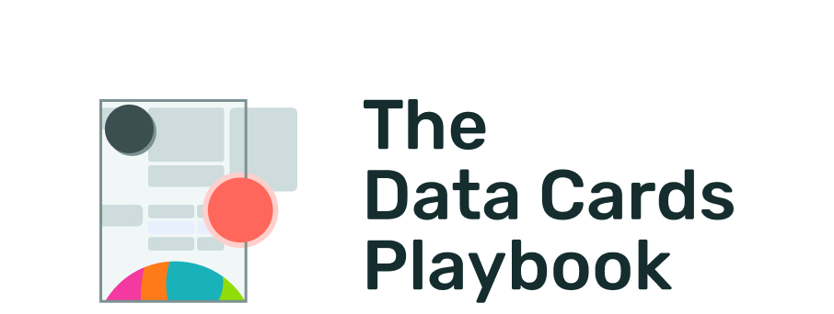
pair-code.github.io/datacardsplaybook

MODULE AUDIT

Implementation Checklist
Activity
Level: Basic
Duration:⏳️

Instructions
Before publicly launching or releasing a completed Data Card, review this checklist to ensure that your implementation addresses basic needs that can drive the adoption and use of your Data Card and the corresponding dataset.

Implementation Checklist

- Discoverable: The Data Card is easily discoverable along with the dataset, or in any academic literature that cites or uses the dataset.
How: Double check that its associated academic literature citation points directly to the Data Card, and vice versa. The same goes for any document, website, repository or platform. Readers should also be able to discover the dataset from viewing the Data Card.
Your notes:
- Shareable: The Data Card can be shared as a standalone document, or along with the dataset without any changes required.
How: Ensure that the Data Card is shareable across any format (PDF, Markdown) or storage (GitHub, sharable file in a cloud storage service) used by the Data Card.
Your notes:
- Feedback & Recourse: There is a clear path for readers to submit feedback, point out errors, suggest additions, ask questions, seek recourse or engage with producers as acceptable on or along with the Data Card.
How: Ensure that there is at least an email address, or a link to a portal, form, or feature request page that a reader can use in case they need to provide feedback – or for a data contributor to seek recourse or get their data removed.
Your notes:

- Future-proofed: The Data Card has been implemented such that it can be meaningfully updated in the future when the dataset is updated, or more information is made available.
How: Include any maintenance plans in the Data Card itself, ideally in a dedicated section that reader can easily find. Update this regularly, and plan for alternative publishing methods if necessary.
Your notes:
- Accessible: The Data Card has been implemented in ways that make it accessible to people with disabilities and accords with accessibility principles.
How: See Material Foundation - Accessibility for a list of guiding principles to enhance the usability of your Data Card for all users.
Your notes:

The Data Cards Playbook ↗ by Google Research is licensed under a Creative Commons Attribution-ShareAlike 4.0 International License.
You are free to share and adapt this work under the appropriate license terms ↗.

