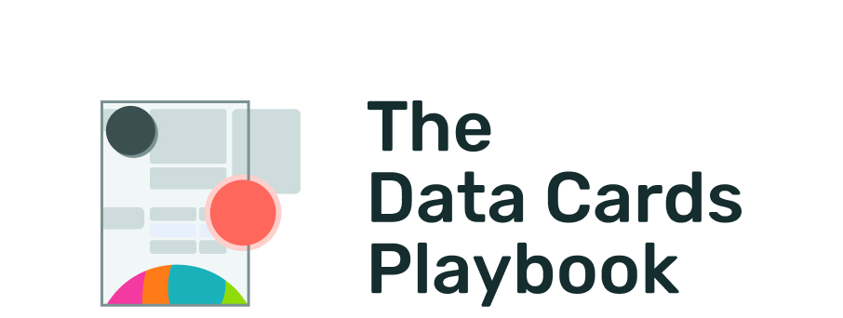
pair-code.github.io/datacardsplaybook

MODULE ANSWER

Scenarios of Maturity Checklist
Activity
Level: Basic
Duration:⏳️

Instructions
Updates to a Data Card can look like both upstream and downstream additions, removals, or revisions. Use this checklist to think through and plan for a variety of scenarios which can prompt you to revisit your Data Card.

Scenario Maturity Checklist
Develop a strategy to update your Data Card for each of the following scenarios:
- A new feature or label is added to your dataset
- Datapoints or features from your dataset need to be removed
- A new analysis reveals a skew in your dataset
- Surprising results are reported when:
  - Your dataset is joined with another dataset
  - Your dataset is used in a new domain
- A new version of your dataset is made available to the public
- Changes to an upstream source that can significantly alter the contents of your dataset
- Changes to the access, wipeout, or retention policies of your dataset

The Data Cards Playbook ↗ by Google Research is licensed under a Creative Commons Attribution-ShareAlike 4.0 International License.
You are free to share and adapt this work under the appropriate license terms ↗.

